Modern Application Development – 1

VEHICLE PARKING APP

Author:
Name: Disha Dash
Roll No: 24f1000618
Email: 24f1000618@ds.study.iitm.ac.in

My name is Disha Dash and I am currently undertaking my diploma in the BS Data Science degree offered by IIT Madras.
Along with this degree I am also pursuing B.Tech in ECE at PES University and have completed my second year in it.

Description:
The vehicle parking app consists of one admin and multiple users. The admin can create parking lots with parking spots, edit and delete the lots based on occupancy in the admin dashboard while the users can book a parking spot in whichever lot they desire and release that spot in the user dashboard.

Technologies used:
- Flask is used for application back-end
  - Technology/Library used:
    - Flask: handles HTTPS requests
    - render_template: renders HTML pages using Jinja2
    - request: deals with data from HTML forms (GET, POST)
    - flash: flashes alert messages
    - url_for: builds urls for routes dynamically
    - redirect: redirects to a different route
    - session: maintains user data from the current session
  - Extension used:
    - Flask-SQLAlchemy: ORM used to interact with the SQLite database
- Jinja2 for templating
  - used for rendering python like commands in HTML
- HTML, CSS are used for application front-end
  - Used to design and style webpages
- SQLite for database
  - Lightweight relational database used to store data in tables

DB Schema Design:

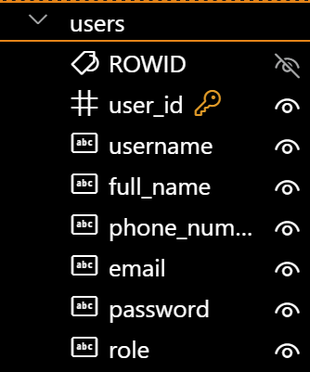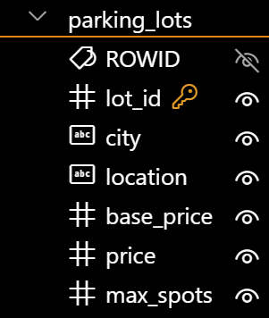
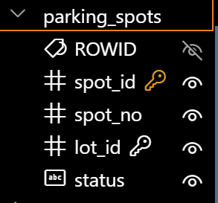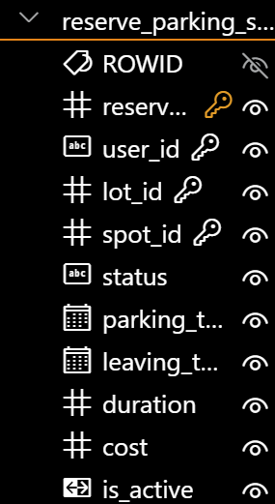

- user_id, lot_id, spot_id and reserve_id are the primary keys for the tables, users, parking_lots, parking_spots and reserve_parking_spots respectively.
- Lot_id is the foreign key in the table parking_spots
- User_id, lot_id and spot_id are the foreign keys in table reserve_parking_spot

API Design:
- /register:
  - for user registration
- /user_login and /admin_login:
  - for login
- /create_lot, /edit_lot, and /del_lot:
  - for managing the parking lot
- /book_spot/<int:lot_id> and /release_spot/<int:spot_id>:
  - for booking and releasing parking spots
- /user_parking_history and /admin_parking_history:
  - to get the parking records of the users
- /admin_summary_charts and /user_summary_charts:
  - to view the summary charts of the users parking history

Architecture and Features:
The project, Vehicle Parking App, is organised inside the folder MAD1.
- templates:
  - stores all HTML pages
- static:
  - contains style.css i.e the file where CSS styling is carried out
- instance:
  - contains the database, parking.db
- app.py:
  - python file where all backend code is written using flask

- models.db:
  - the file where the database is defined
- _pycache_:
  - caches compiled python files automatically
- myenv:
  - contains virtual environment dependencies

The core features of the app involve:
- Admin and User logins:
The admin is predefined, if the user doesn’t have a login he/she can register themselves.
- Admin Dashboard:
Admin can create parking lots, edit the pricing of the parking lot or delete the parking lot altogether provided that none of the parking spots in that lot are occupied.
Admin can also view the parking history of all the users and view summary charts of lots used per user and parking spots occupied per user.
- User Dashboard:
The user can book a parking spot in a parking lot of user’s choice. Once a parking spot is booked, the book spot option is disabled and the user can release the spot as and when he/she wishes.
They can vacate their spot either by clicking on the release spot option on dashboard or through the release spot button in parking history. On releasing the spot, the user is shown the amount to be paid at counter.
The user can also view their parking history and summary charts for spots per parking lot.

Both user and dashboards also include a log out button to log out of their accounts.

Video:
https://drive.google.com/file/d/1VOXgykbMlDKVLGOCNrryYAZ0PBlhnuGV/view?usp=sharing

